**BIC Coursework:**

**Introduction :**

Machine learning is now an established tool when it comes to solving classification problems. Recent developments are evolution of the perceptron; a linear classifier and as such has limited effectiveness with real world problems with multiple dimensions. They work by applying weights and biases to the input layer and, through the use of an activation function such as the sigmoid function, make predictions on the class of a given input. Artificial Neural Networks (ANNs) are, in essence, a collection of perceptrons (‘neurons’) working in discrete layers to achieve their predictions and is based off the human brains and its synapses. They consist of 3 main features, an input layer, a hidden layer and an output layer. There can be many hidden layers, which is where the term ‘deep learning’ originates. These neurons are connected by to one another by synaptic weights that, during the networks training process, the ANN updates based off user defined process, classically gradient decent. Once trained it is essential to test the network on separate data to the training set, to assess the models generalisation ability and further assess its predictive accuracy.

Many classic ANNs are limited by their inability to provide adequate accuracy rates out with training but also cannot explore multimodal and noncontinuous surfaces. Evolution of such ANNs is therefore necessary if real world application is to be achieved successfully. The main features of an ANN that limit its effectiveness are its topology, its transfer functions and it set of synaptic weights and biases. Efforts to improve ANNs therefore predominantly focus optimising these areas.1 Biologically Inspired Algorithms (BIA) aim to optimise such features to make ANNs more generalisable.2 They allow for exploration of multimodal and non-continuous search spaces, thus rectifying some limitations of ANNs. There are two main fields in which solutions are proposed, namely evolutionary optimisation and swarm optimisation.3 In this paper we will focus on Swarm intelligence. Swarm intelligence is a BIA development composed of naïve units that, when working in unison, produce intelligent behaviour, likened to bird flocking or fish schooling in nature.4 These metaheuristic methods of training utilise different techniques such as population methods and co-operative evolutionary models.5 PSO is an ANN optimisation technique using information on the position of its best particle in the population and memory of prior experiences of its members. 6 A particles multidimensional location within the search space is evaluated using an optimisation function, its current position and population best position are tracked. In each iteration a particles position is updated in an attempt to find a new optimum and compared against the best previously found across all particles in the population. This report outlines how an ANN was constructed in python and optimised using PSO, without using traditional machine learning packages.

**Artificial Neural Network :**

An ANN is a collection of neurons arranged into layers, which are then linked together to form a network. Each neuron (Fig.1) within the network uses an activation function product of the weights, biases and input to produce a result that it then propagates to the next hidden layer, or makes a prediction if this layer is the output layer. The activation function has a large impact on the result of the network. All have activation functions have their drawbacks such as the vanishing gradients problem in the case of sigmoid or tan or result in a dead neuron in the case of ReLU().

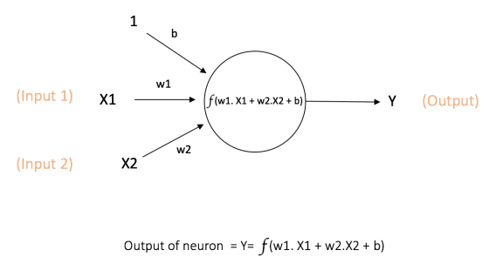

Figure - A Neuron, it takes a number of inputs and applies a weight to each and lastly adds a bias to produce an output

A simple ANN structure is shown in Fig.2, performing a ‘forward pass’, this would classically be followed by a backpropagation techniques to improve weights and biases such as gradient decent. Each. In this case, tje result is passes onto subsequent hidden layers (if any) with the final output layer often using a softmax formula to made the prediction. neuron utilises an activation to this would later be optimised by PSO. Its number of layers and neurons within those layers are programmable to allow complete control to the implementer. A NN is a collection of layers of ‘neurons’ linked in a network to attempt to make accurate predictions having first been trained on. Its base unit is the perceptron shown below in

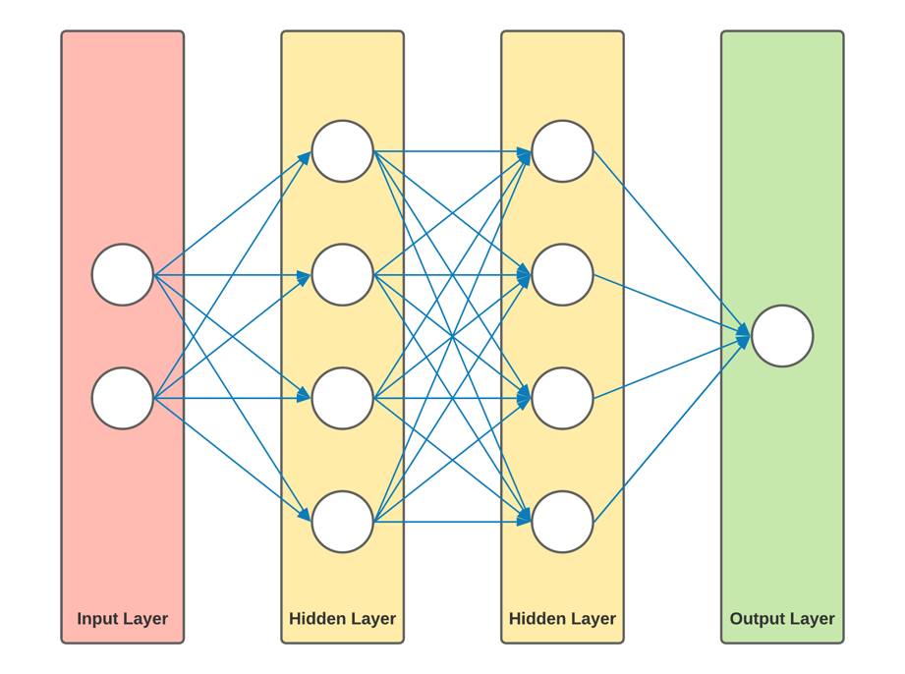

Figure - Neural Network consisting of 3 main layers including the input layer, and 4 overall layers

.

**Particle Swarm Optimisation :**

PSO Velocity Update Formula

V*i*(*t*+1) = ωV*i*(t) + *c1r1*(**P**i(*t*)-X*i*(*t*)) + c2r2(Pg(*t*)-Xi(*t*))

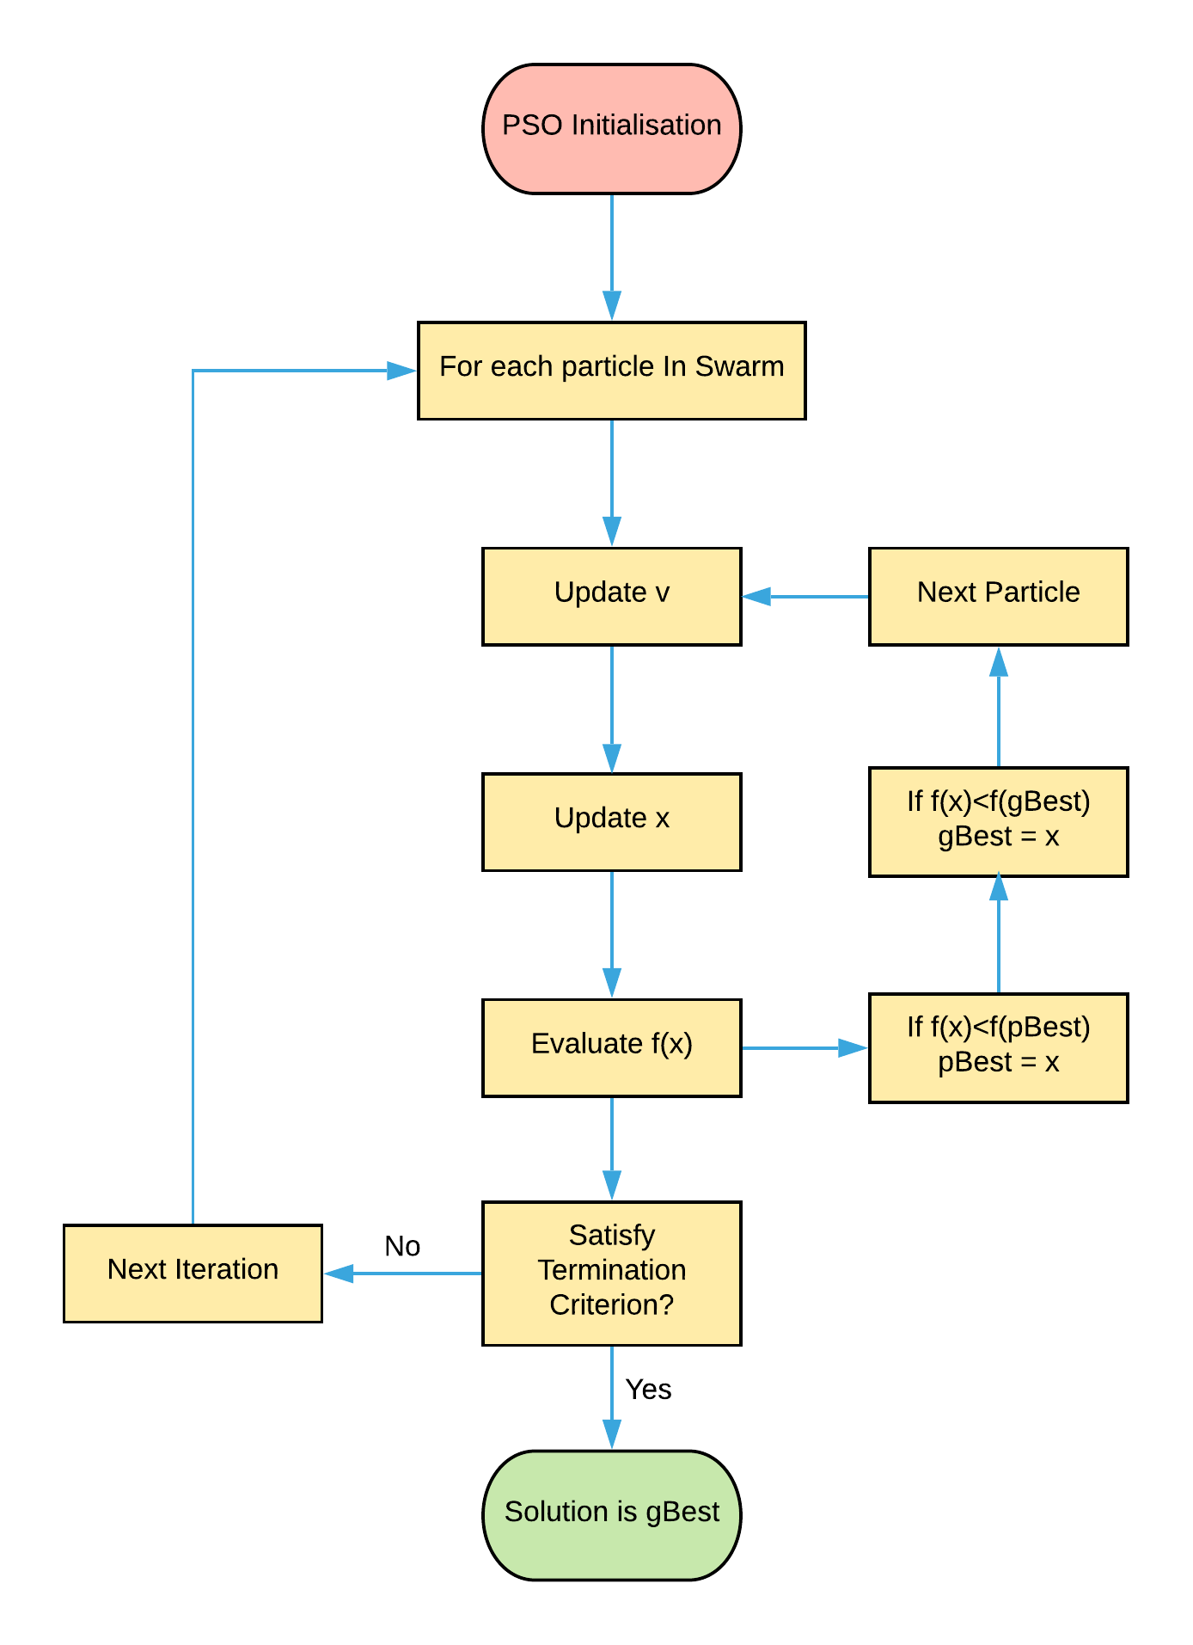

Figure Flow diagram of a PSO, v = velocity, x = position of particle, f(x) = fitness of current location, gBest = best position found by all particles.

**References :**

1. Yao, X. Evolving artificial neural networks. *Proc. IEEE* **87**, 1423–1447 (1999).

2. Rivero, D. & Periscal, D. Evolving Graphs for ANN Development and Simplification. *Encycl. Artif. Intell.* 618–620 (2011). doi:10.4018/9781599048499.ch094

3. Angeline, P. J. Evolutionary optimization versus particle swarm optimization: Philosophy and performance differences BT - Evolutionary Programming VII. in (eds. Porto, V. W., Saravanan, N., Waagen, D. & Eiben, A. E.) 601–610 (Springer Berlin Heidelberg, 1998).

4. Eberhart, R. & James Kennedy. A New Optimizer Using Particle Swarm Theory. *Sixth Int. Symp. Micro Mach. Hum. Sci.* **0**-**7803**–**267**, 39–43 (1999).

5. Alba, E. & Martí, R. Metaheuristic Procedures for Training Neural Networks Operations Research / Computer Science. *Computer (Long. Beach. Calif).* 252 (2006).

6. Kennedy, J. Swarm Intelligence BT - Handbook of Nature-Inspired and Innovative Computing: Integrating Classical Models with Emerging Technologies. in (ed. Zomaya, A. Y.) 187–219 (Springer US, 2006). doi:10.1007/0-387-27705-6_6